Colorado EHDI
Screening Task Force

Meeting Notes
September 14, 2021

Attendees
Name | Role
Heather Abraham | Facilitator & Notetaker
Becky Awad | Pediatric Audiologist, Children’s Hospital
Arlene Stredler Brown | Facilitator
Katie Cue | Colorado Commission for the Deaf, Hard of Hearing, Deafblind - Outreach Specialist; & Colorado EHDI
Maureen Cunningham | Hospitalist; Children’s Hospital
Deb Draus | Educational Audiologist, Littleton Public Schools
Jillian Gerstenberger | Pediatric Audiologist & Chief Operations Officer, Pediatrix
Leanne Glenn | Newborn Hearing Screening Coordinator, CDPHE
Angela Harder | Audiology Assistant, Children’s Hospital
Brian Herrmann | Pediatric Otolaryngologist, Children’s Hospital
Sara Kennedy | Director, CO Hands & Voices
Annette Landes | CO-Hear Coordinator; North Region
Dawn O’Brien-Taylor | Pediatric Audiologist, Colorado Springs
Ashley Renslow | CSDB; Early Education Consultant
Kristin Sommerfeldt | Audiologist & Instructor; University of Colorado-Boulder
Dee Woodard | CO-Hear Coordinator; Western Slope Region

Agenda Overview
Outcomes:
- Finalization of NBHS Brochure for recommendation to Alliance
- Explore intended outcomes for COEHDI regional collaborations

Agenda:
- HIDS Update
- Update on Newborn Hearing Screening Brochure
- Identify Outcomes and Goals for COEHDI Regional Collaboration - Focus on Screening

Agenda/Actions/Decisions
Agenda Items | Discussion | Action/Decision
HIDS Update | The current total of 146 \ HIDS users fall into these categories: (a) 63 screeners; (b) 17 midwives (1 is reporting for 7 midwives, 2 are reporting for 10 midwives, one audiologist is reporting for 4 midwives which is a total of 35 midwives); (c) 51 audiologists (includes 13 educational audiologists); (d) 13 early intervention personnel; and (e) 2 PCPs.  CDPHE has updated letters that are sent to parents. One is for children who miss a screena; the second is for children who need a rescreen. The letters have been translated into Spanish. | n/a
NBHS Brochure | The writing of this brochure was done by a variety of stakeholders including the writing subcommittee of this task force. Additional changes were proposed, and agreed to, at today’s meeting:  - Rearrange the content in the first paragraph  - Insert “We cannot know why your baby did not pass their screen without further testing.”  - Remove copy stating, “even if your baby was born there”  - Add more options for contacts for screening and rescreening.  - Be sure the brochure is sensitive to midwives; they initiated the request for a brochure.  - Consistent use of red titles and black text  After making the above-mentioned copy edits, the task force members unanimously approved the brochure moving forward.
Goals & Outcomes for Regional Collaborations | Some background was presented to provide context to support newborn hearing screeners.  - 2019 Screening Data: While 95% of babies were screened in our state, this falls short of the national statistic of 98%.  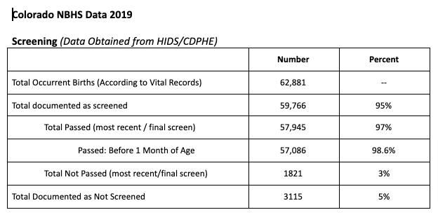  - Pediatrix/Mednax screens approximately one third of the children born in Colorado. They will continue to do inpatient screens and outpatient screens. Effective September 1, 2021, they will no longer provide care coordination (which has traditionally tracked children to assure they have a hearing screen and/or get hearing tested if they do not pass the screening).  - CDPHE has issued reports to all birthing facilities for the first quarter of 2021. The intent is for CDPHE to generate quarterly reports. Only hospitals receive the data.  - The 2019 JCIH Position Statement includes eight goals for NBHS. These goals provide guidance for acceptable standards.  Currently, the CDPHE, CIHAC and COEHDI are all involved, to varying degrees and with varying activities, in regional collaborations. Leanne Glenn stated that CDPHE will not change its stance on data sharing. Data will be sent exclusively to birthing facilities. Becky Awad expects this concern about data sharing to be discussed at the October meeting of the CIHAC.

Next Meetings

Meetings of the Screening Task Force are on the 2nd Tuesday of each month from 11:00 - noon.
DATE | TIME | AGENDA ITEMS
10/10/21 | 11:00-12:00 | TBD
11/9/21 | 11:00-12:00 | TBD

A note about accommodations: Beginning February 1, 2021, all Alliance meeting and task force meeting accommodations (e.g., American Sign Language interpreters, Cued Language Transliterators, and/or Spanish translators) must be requested at least 72 business hours or 3 business days in advance. Requests may be made by contacting your task force facilitator. We will also enable Zoom's Live Transcription feature for all meetings.

