Colorado EHDI
Screening Task Force

Meeting Notes
August 9, 2022

Attendees
Name | Role
Heather Abraham | Facilitator & Notetaker
Arlene Stredler Brown | Facilitator
Stacy Stiell (Claycomb) | Audiologist; University of Colorado Health (Oversight of Hearing Screening for UC Health Anschutz and Highlands Ranch
Leanne Glenn | Newborn Hearing Screening Coordinator; CDPHE
Hannah Glick | Audiologist and Lecturer, CU-Boulder; Contract audiologist with COEHDI
Kristin Sommerfeldt | Audiologist & Clinical Asst Professor; University of Colorado-Boulder; Contract Audiologist with COEHDI
Becky Awad | Audiologist; Children’s Hospital of Colorado
Angela Harder | Audiology Assistant, Colorado Children’s Hospital Colorado Springs

Agenda Overview
Agenda
- Update on Virtual Site Visits (VSV) - Kristin Sommerfeldt & Arlene
- Update on Roadmaps - Arlene

Agenda/Actions/Decisions
Announcements | Stacy Stiell: Stacy now has oversight of newborn hearing screening at two UCHealth locations (Anschutz and Highlands Ranch).
Virtual Site Visits (VSVs) | VSVs are led by a collaborative team including Kristin Sommerfeldt and Jami Fries as co-leads, Kirsten Nelson (pediatrician), the CO-Hear Coordinator for the birthing facility’s region, and Arlene. VSVs provide an opportunity to ask each facility about their NBHS processes and to identify their strengths and needs. Each member of the VSV team offers recommendations, answers questions, and provides resources that match the needs of the birthing facility after the VSV. Either Kristin Sommerfeldt or Hannah Glick are available to provide audiology-focused technical support on an ongoing basis.  Pediatrix is contracted by many hospitals in Colorado. Up to three people from Pediatrix have been attending the VSV. Because there is consistency in practices when Pediatrix is contracted, the VSV team is considering an adjustment to the interview questions. Questions for VSVs at facilities contracting with Pediatrix may be shortened and focus only on practices (e.g., cCMV) that are not included within Pediatrix’s scope of work.  A visual representation of themes was presented by Hannah Glick. These themes will be published in the September/October issue of the COEHDI newsletter and in an upcoming issue of the NBHS Monthly. It is included here.  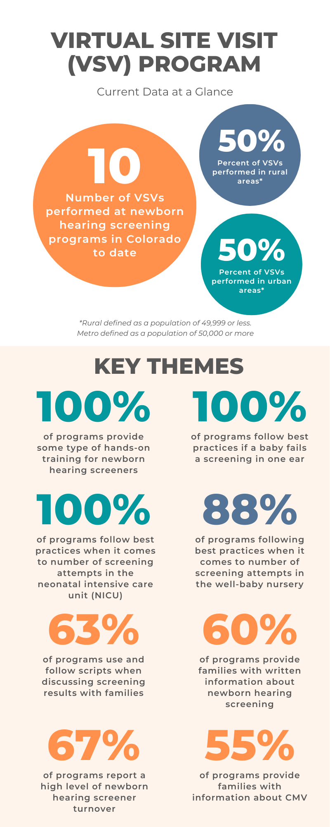  Discussion points include:  - All facilities have some form of screener training in place. However, the components of the training vary greatly among facilities. There is often a lack of a designated training curriculum. Some birthing facilities use the NCHAM training curriculum. Many facilities supplement a training curriculum with additional resources.  - Most programs are following best practices when a baby does not pass the hearing screening in one or both ears.  - For sites with a NICU, most follow best practices for the number of screening attempts (two attempts for the initial, inpatient screen; two attempts during a followup screen).  - In well-baby nurseries, there is variability in adherence to best practices. After the VSV, the VSV team provides resources to help each facility to adhere to best practices.  - Sixty-three percent of programs that have had VSVs use scripts when discussing results (e.g., pass, did not pass) with families.  - About 60% of programs that have had a VSV to date provide families with written information supporting follow-up. By and large, many facilities are aware of and have access to the COEHDI NBHS brochure. Some facilities use their own proprietary materials. It was noted that COEHDI did a mass mailing of brochures to all birthing facilities and midwives. To date, COEHDI has received orders for approximately 1000 copies of the English brochure and 400 copies of the Spanish brochure. Many requests are from midwives.  - There are frequently high levels of screener turnover. This can add to the challenge of running an effective NBHS program. Most sites assign screening to RNs and/or medical assistants. Some include volunteers.  - Many programs do not yet conduct cCMV screening. Approximately 50% of birthing facilities provide families with information about cCMV.  - In rural birthing facilities, many have all of their staff trained to conduct hearing screenings. Urban sites tend to have dedicated staff for screening.  In general, resources and information shared by the VSV team have been well-received by birthing facilities. Most facilities are unaware of the NCHAM training.  Of the VSVs conducted to date, one site reported that they did not receive their screening data from CDPHE; Arlene connected them to Leanne to remediate this. In general, most sites are not analyzing their screening data and they are unaware of how to utilize the data to improve their program. At the August CIHAC meeting, some asked to add the JCIH goals (e.g., 98% screened before hospital discharge) to the quarterly report. Hannah Glick requested a copy of a blank template that is shared with birthing facilities; she will include this in a future issue of the NBHS Monthly along with a guide for interpretation. Leanne reported that CDPHE does not have the capability to monitor if those receiving the quarterly reports are opening the email. She hopes to have this capability in the future.  It has been time consuming to identify birthing facilities to participate in VSVs. Members of this task force were asked for ideas on ways to solicit participation. One suggestion is to invite hospitals that are in transition. Becky Awad suggested looking at systemic programs (e.g., satellite sites from the bigger hospital networks) to identify those birthing facilities that have high turnover in their programs. A review of the birthing facilities that contract with Pediatrix and Envision can also be pursued. Kristin or Jami can connect with the audiologist in a community, especially rural communities, to identify which hospitals may benefit from a VSV.  The VSV team aims to conduct two VSVs per month; this is based on funding, and consequently, time limitations. The task force members suggested maintaining an equal distribution of rural and urban birthing facilities.
CO Hands & Voices Roadmaps | Colorado Hands & Voices has historically created Roadmaps that are specific to each birthing facility’s staff and geographic region. Updating these takes a lot of time and effort due to frequent changes at birthing facilities. COEHDI is working with Jami Fries to create a generic version of the Roadmap. This version is almost ready for distribution.  The hospital-specific version of the Roadmap also has merit. Jami Fries will be asked to report on this at a future meeting. | Screening Task Force members will be included in the distribution of the generic Roadmap when it is finalized.

Next Meeting
DATE | TIME | AGENDA ITEMS
September 13, 2022 | 11:00-12:00 | TBD

All Alliance meeting and task force meeting accommodations (e.g., American Sign Language interpreters, Cued Language Transliterators, and/or Spanish translators) must be requested at least 72 business hours, or 3 business days, in advance of the meeting. Requests may be made by contacting your task force facilitator. We will also enable Zoom's Live Transcription feature for all meetings.

